ST BENEDICT’S COLLEGE



|  |  |  |  |
| --- | --- | --- | --- |
| **SUBJECT** | Information Technology | **DATE** | November 2016 |
| **GRADE** | 11 Practical Exam | **MARKS** | 120 |
| **EXAMINER** | Mrs Kench | **MODERATOR** |  |
| **NAME** | **Bennetts** | **DURATION** | 3 Hours and 30min printing |
| **USER NAME** | **hsexam42** | **PASSWORD** | **M4018** |
|  |  |  |  |

|  |  |  |  |  |  |
| --- | --- | --- | --- | --- | --- |
| **COGNITIVE LEVELS** | | | | | |
| LOW ORDER | 31 % | **MIDDLE ORDER** | 43 % | HIGH ORDER | 26 % |

|  |  |
| --- | --- |
| INSTRUCTIONS |  |
| COMMENT |  |
|  |  |
|  |  |
| TEACHER’S SIGNATURE |  |
| PARENT’S SIGNATURE |  |

SECTION A: SQL

**SCENARIO**

Water is one of the most essential commodities required for the survival of human beings, plants and animals. The Department of Water Affairs is embarking on an intensive campaign to help save water. Many measures and programmes have been put in place to help bring about awareness on how to use water sparingly.

The Department of Water Affairs has created a database named **DamsDB** containing information on all the dams in the country and the towns to which they supply water.

**Table designs:**

**tblDams**

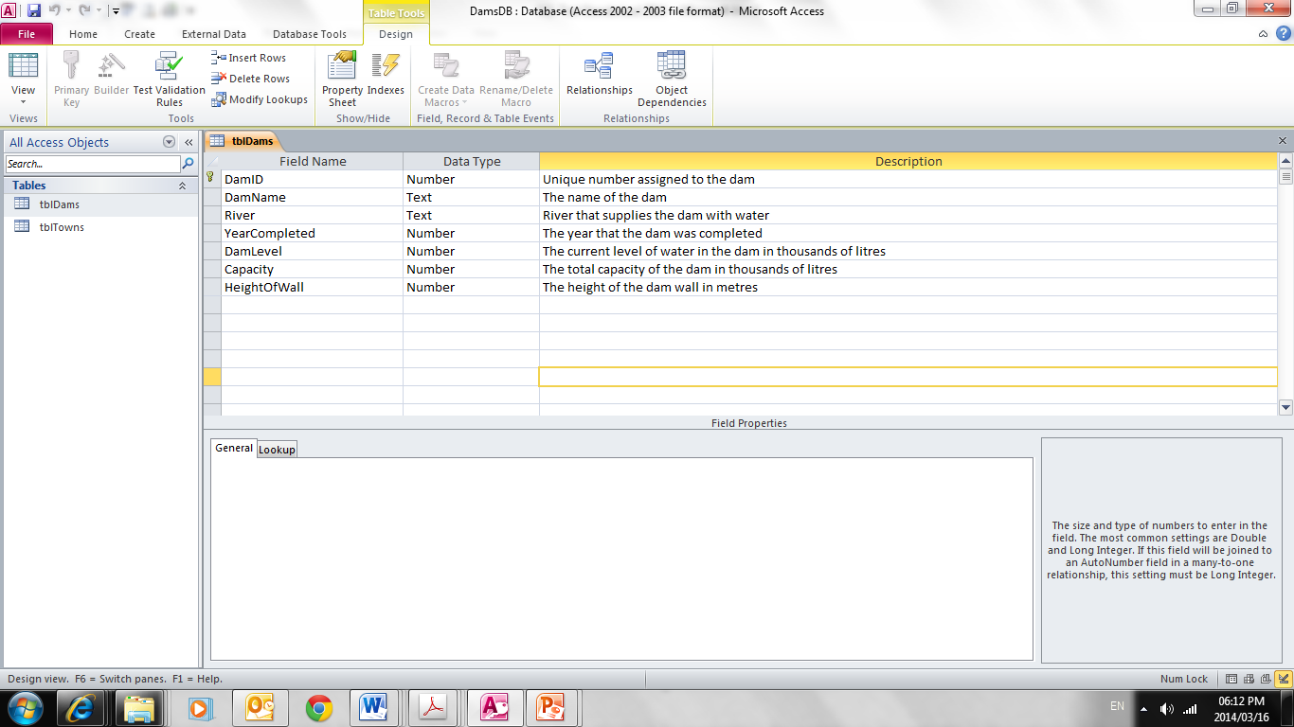 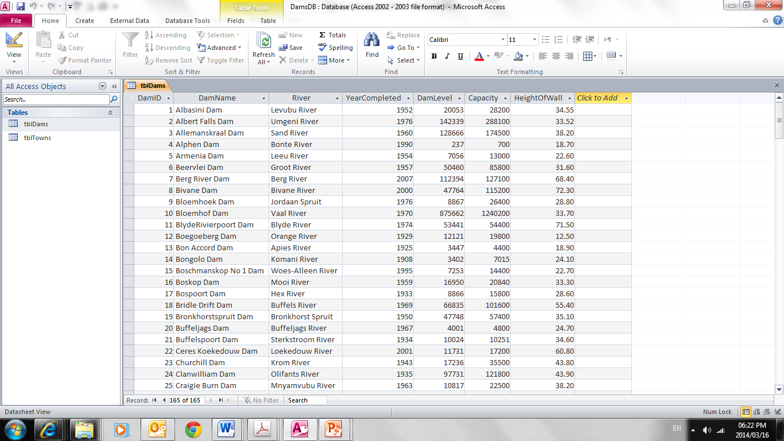   
**tblTowns**

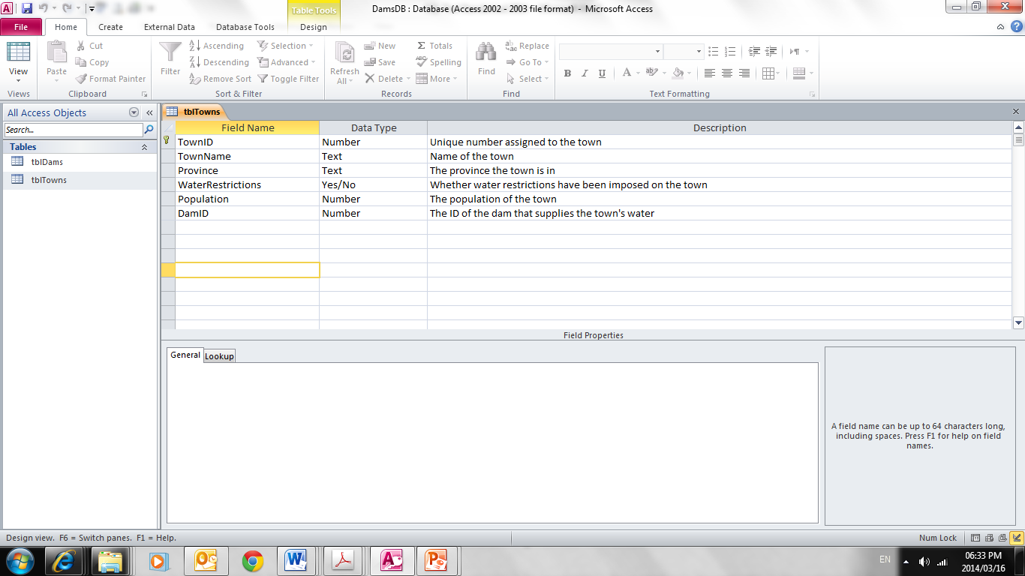

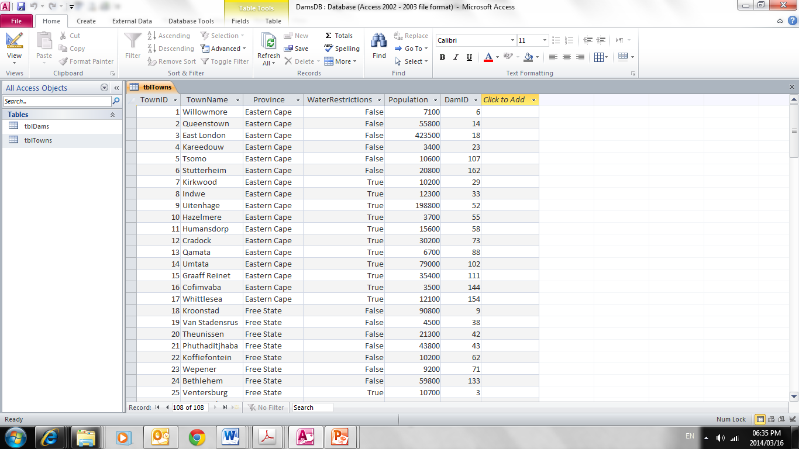

**Question 1**

1. The Department of Water Affairs wants a list of all the dams in the country, sorted alphabetical according to the river and then the name of the dam. (3)
2. One of the main concerns is large urban towns and water shortage. The Department wants a list of names of all the towns in all the different Cape provinces that have a population exceeding 100 000 and where they experience water restrictions. List the **TownName**, the **Province** as well as the **Population**. (6)
3. Some analysts have indicated that the **North West** province will experience severe droughts in the coming years. They have recommended that water restrictions be imposed on all towns in this province. Update the records of all towns in the North West province. (3)
4. After an audit by the Department of Water Affairs they realise that the water shortage in North West can become a disaster in the future. They decided that a new dam, called **Saviour Dam** must be built in the Christiana area. The DamID will be **165**, the dam will feed from the **Vaal River** and they predict that it will be completed in the year **2020**. The rest of the properties will be added at a later stage. Formulate a SQL statement to add the new dam to the table tblDams. (3)
5. The Department would like a list of all the dams that are below 40% full. Provide a list of the dams including the name of the dam and the calculated capacity. Name the calculated capacity as **CapacityPerc**. (4)
6. The Department wants to know the average population of each province. List the name of the province followed by the average using the table tblTowns. (4)
7. The Department of Water Affairs considers any town with water restrictions to be a 'critical town' and wants to know how many critical towns there are in each province. Display the Province and the total number of critical towns in that province. Name the calculated field **CriticalTowns**. ***Only display where the provinces have more than 5 critical towns***. (7)
8. Some dams need repairs. List the top 10 oldest dams. Display the name of the dam and the age of the dam in years with the oldest dam listed first. (5)
9. The Department of Water Affairs wants a **unique code** for every town with a population more than 20000. They want the code to be as follows: The first 4 letters of the Province and then characters 2 to 5 of the TownName, for example **Eastillo.** Formulate a SQL statement to display the **Province**, **TownName** and the **unique code**. (5)

**TOTAL: 40**

SECTION B 80 MARKS

SCENARIO

A programmer new to gaming has designed a card game with 20 characters. Each character has a name, health points, magic points and inventory of three items: a sword, items for healing and a magic item. The sword is made out of either gold, silver, bronze or wood, the healing items are a wand, a bandage and some ointment and the magic items are potion, a chant and a lamp. The details of the 20 characters are stored in a text file called **Character.txt**. Each character has been assigned an integer value for health and magic. The inventory is a list separated by commas.

The first 10 lines of the text file are as follows:

Name#health#magic#inventory

|  |
| --- |
| Hellboy#47#27#silver,bandage,chant  Darth Vader#46#39#gold,ointment,lamp  Harry Potter#39#24#wood,ointment,lamp  Han Solo#12#21#gold,ointment,lamp  Yoda#18#35#silver,wand,potion  Buffy#39#29#silver,bandage,chant  Godzilla#10#39#gold,bandage,chant  Ellen Ripley#44#22#bronze,wand,potion  Agent Smith#34#33#bronze,bandage,chant  Neo#37#37#bronze,ointment,lamp |

Question 2 33 marks

2.1 Create a class called **Card** with fields to store the **name**, **health**, **magic** and **inventory**. Use appropriate types for each field. (4)

2.2 Code a parameterised constructor to assign values to the fields. (3)

2.3 Overload the constructor to accept a parameter for the **name** of the Card and randomly generate values for the **health**, **magic** and **inventory** fields. The **health** value must be a number between 10 and 50 (inclusive) and the **magic** value must be a number between 20 and 40 (inclusive). The **inventory** must be made up of three items separated by a comma, namely a sword, a healing item and a magic item. Use the table below to choose one value for each of the sword, healing item and magic item. Combine the three values into a String separated by commas. Marks will be awarded for efficiency.

|  |  |
| --- | --- |
| sword | gold silver bronze wood straw |
| healing | wand bandage ointment |
| magic | potion chant lamp |

(9)

2.4 Code accessor methods for the **name**, **health** and **magic** fields. (3)

2.5 Code a method called **changeSword** to change the type of sword for a character stored in the inventory filed. The new type of sword must be sent as a parameter. The method must change the inventory field.

For example the inventory list:

silver,bandage,chant

must change to

gold,bandage,chant

if “gold” is sent as a parameter.

(5)

2.6 Code a method called **updateCard** to increase the health and magic fields by certain values. The value to increase each field will be sent as a parameter for both the health and magic fields. In addition a new value will be sent for the type of sword as a parameter. Use the method **changeSword** that you coded in 2.6 to help you. (4)

2.7 Code a **toString** method to display each Card object as follows:

Hellboy 47 27

Inventory: silver,bandage,chant

(5)

Question 3 42 marks

3.1 Code a class called **CardArray** to store 20 Card objects and a variable to record the number of Card objects in the array. (4)

3.2 Code a constructor to instantiate the array of cards using the text file **Character.txt**. (8)

3.3 Code a **toString** to display each card separated by a blank line. (5)

3.4 Code a method to **sort** the array according to the character name in alphabetical order. (8)

3.5 Code a method called **find** to return a Card object given the position of the card in the array. (3)

3.6 Code a method called **delete** to remove a Card object from the array given the position of the card in the array. (5)

3.7 Code a method called **playGame** where a card will be generated by the computer to play against a random card selected from the **CardArray**. Use the overloaded constructor you coded in question 2.3 to create a Card object for the computer with the name of “Gollum”.

The randomly selected card from the **CardArray** must be played against the computer’s card with the name “Gollum”. If the selected card has more health and magic points than the computer’s card, then the selected card wins and the selected card’s health and magic points are increased by the computer card’s health and magic points. If the selected card loses, it is removed from the **CardArray** and the CardArray must be displayed to show the card has been removed. (9)

If the selected card wins, the output should be returned as follows:

Computer

Gollum 12 28

Inventory: wood,ointment,chant

Card from array

Terminator 46 32

Inventory: silver,ointment,lamp

Card wins - updated

Terminator 58 60

Inventory: gold,ointment,lamp

If the computer wins the output should be returned as follows:

Computer

Gollum 42 30

Inventory: straw,bandage,chant

Card from array

Optimus Prime 30 39

Inventory: bronze,bandage,chant

Card lost - card destroyed

Agent Smith 34 33

Inventory: bronze,bandage,chant

Bender 47 25

Inventory: bronze,bandage,chant

Buffy 39 29

Inventory: silver,bandage,chant

Chewbacca 11 25

Inventory: bronze,wand,potion

Darth Vader 46 39

Inventory: gold,ointment,lamp

Data 44 34

Inventory: gold,ointment,lamp

Ellen Ripley 44 22

Inventory: bronze,wand,potion

Frodo 47 30

Inventory: wood,wand,potion

Gandalf 48 30

Inventory: straw,bandage,chant

Godzilla 10 39

Inventory: gold,bandage,chant

Han Solo 12 21

Inventory: gold,ointment,lamp

Harry Potter 39 24

Inventory: wood,ointment,lamp

Hellboy 47 27

Inventory: silver,bandage,chant

Neo 37 37

Inventory: bronze,ointment,lamp

Robocop 26 21

Inventory: straw,bandage,chant

Spock 30 40

Inventory: bronze,wand,potion

Terminator 46 32

Inventory: silver,ointment,lamp

Tron 40 26

Inventory: wood,bandage,chant

Yoda 18 35

Inventory: silver,wand,potion

Question 4 5 marks

4.1 Code an application class called **GameUI** to instantiate a **CardArray** object. (2)

4.2 Add code to display all the details of each card one below the other. (1)

4.3 Add code to display all the details of each card sorted according to the card name. (1)

4.4 Add code to display the result of the **playGame** method. (1)